LEAF 2021 User Guide
- Register and make an account using this link: https://app.ucl.ac.uk/LEAF/LEAF_External.
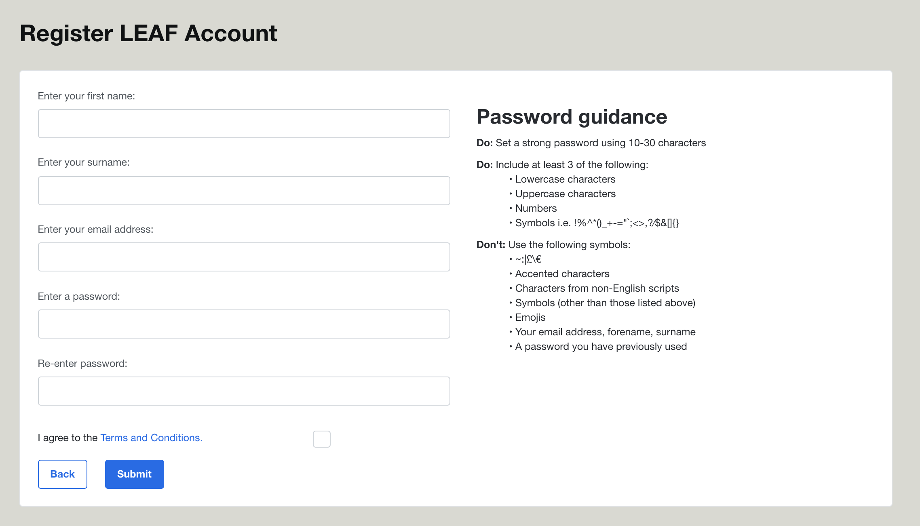
- Once you have made an account, sign in and request lab.
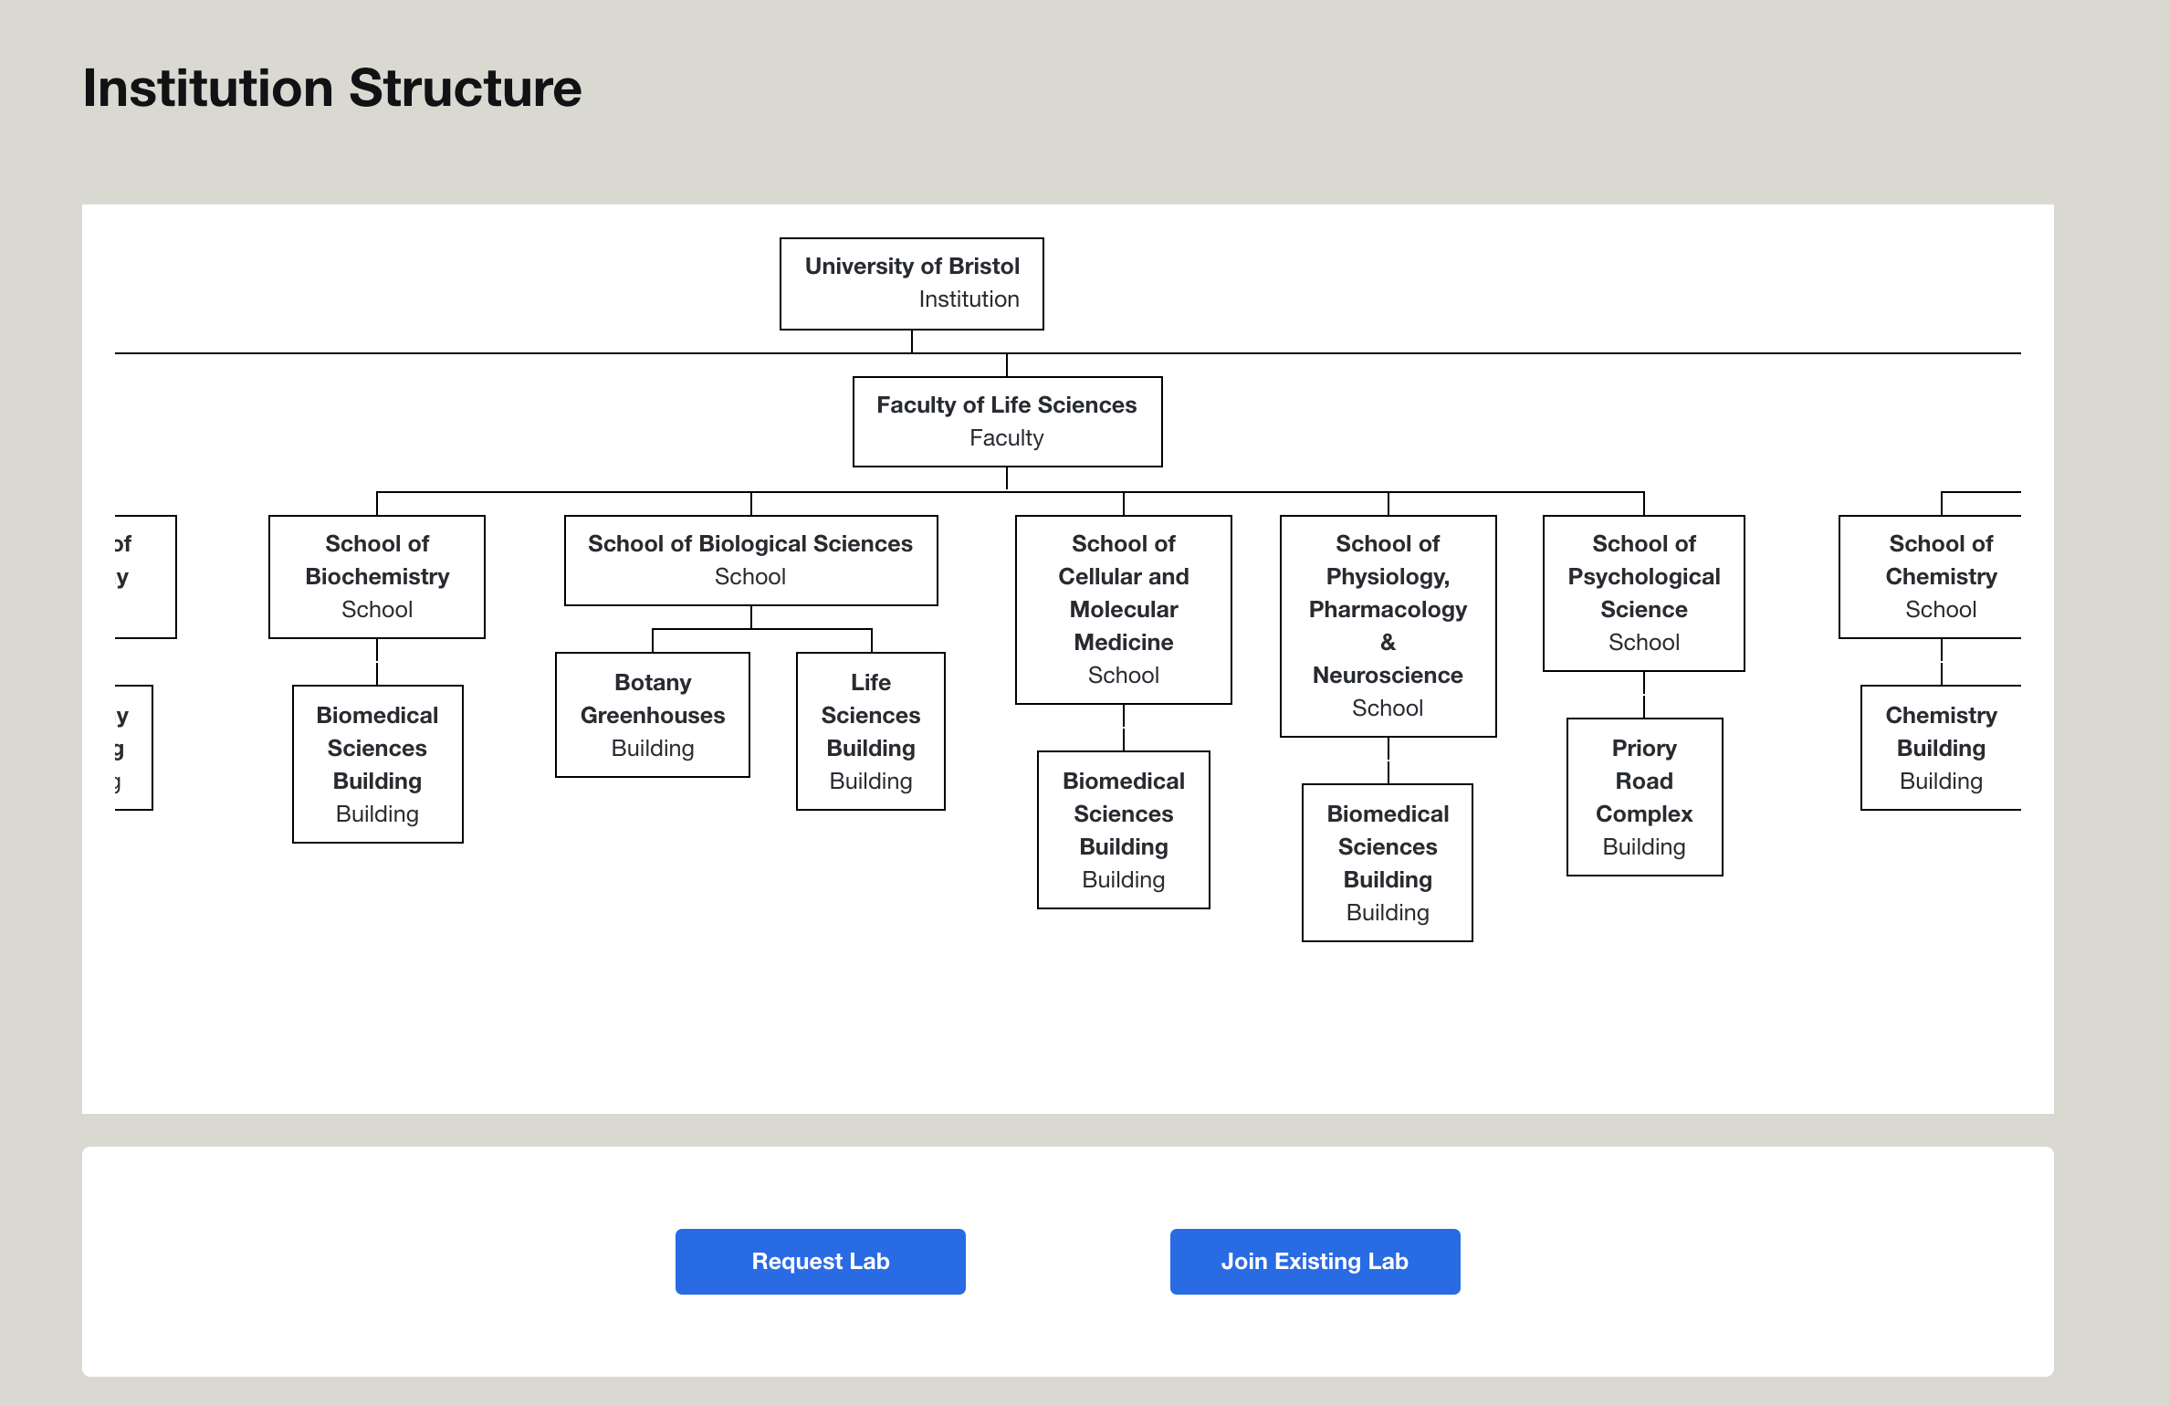
- Fill in your lab’s details to be reviewed and approved.
- Once your lab has been approved, you can begin completing the criteria. If you have completed bronze or silver certification in the past and are going for higher certifications (i.e., silver or gold) you will have to copy and paste your answers from LEAF 2020 (the Microsoft excel document) for the criteria you have completed in the past – this will only have to be done once and will not have to be repeated for future certifications on this online platform.

For any further questions, please contact green-labs@bristol.ac.uk

